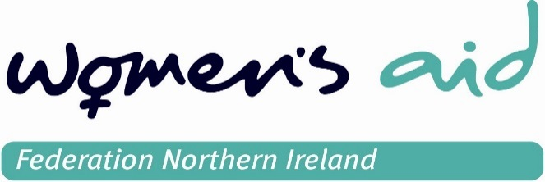

Post advertised is open to women only. For this post being a woman is a genuine occupational requirement in accordance with Article 10 (2) (e) of the Sex Discrimination NI Order 1976 (as amended). In order to comply with the Safeguarding Vulnerable Groups (Northern Ireland) Order 2007 Women’s Aid Federation Northern Ireland are required to explore the successful candidate’s suitability to work with vulnerable adults and children through ACCESS NI pre-employment screening.

Job Advert – Training Administrator
A great opportunity for a part-time Training Administrator has arisen with Women’s Aid to join our team in Belfast.

About the role
We are looking for an enthusiastic individual with the skills and knowledge to support the administration of our training services. The successful candidate will support our Training & Development Coordinator in the successful running of our training department.
The ideal candidate will be able to deliver outstanding customer service whilst maintaining superb administration of the department as we expand our external training provisions and look to become a training centre of excellence.
You will have strong organisational and communication skills and a flexible can-do attitude. We work in a small team and everyone’s contribution must count.
What you will do:
- Monitor customer account management including the pre-course quotations, invoicing and payment processes, reporting any problems to the T & D Coordinator.
- Ensure accurate handling of booking confirmations and delegate joining instructions
- Maintain a register of trainers & training agencies relevant to domestic violence policy & service provision
- Maintain up-to-date resource lists on venues and accommodation for events and conferences
- Maintain the training section of the website
- Assistant with diary allocations for freelance trainers
- Answer all enquiries, provide information and respond to any requests from clients or prospective clients in a prompt and professional manner.
- Collate final details for courses, drawing up and chasing booking contracts, checking and sending final invoices to clients.
- Communicate and liaise with clients and training venues using appropriate methods to facilitate the smooth running of training courses
- Help the T & D Coordinator prepare weekly/monthly reports as required for the management team.
What you will need to succeed:
- Accurate, organised and efficient administration skills.
- To be target driven to achieve the required sales.
- A confident telephone manner, with the ability to problem solve and use your own initiative.
- Excellent IT skills with office packages
- Excellent customer service skills
- Excellent written and verbal communication skills.
- A flexible working attitude, to be able to work as a team and to cover for colleagues when necessary.

About Women’s Aid
Women’s Aid is the lead voluntary organisation in Northern Ireland addressing domestic and sexual violence and providing services for women and children.
The Women’s Aid movement in Northern Ireland began in 1975 and is made up of nine local Women’s Aid Groups and Women’s Aid Federation Northern Ireland.
Each Women’s Aid group offers a range of specialist services to women, children and young people who have experienced domestic violence. They are all members of Women’s Aid Federation Northern Ireland.
Our overarching aim is to provide the required training to enable society to tackle domestic & sexual violence. Through our training, all agencies working within this sector will have access training quality assured training and consultancy.
We recognise that our people are vital to our current and future success.
At Women’s Aid, we reward our employees with a competitive salary and impressive benefits package including a contributory pension and 33 days’ annual leave.
We encourage personal and career development and allow our people to continually develop their skills. We help our people to chart their development course and support the training and in-role experience required to help them realise their ambitions.

What we hope you will do next
Help us find out more about you by completing our short application process. You will need to fill in a paper based form available by contacting reception@womensaidni.org.

